# Experiment No: 15

**Aim**

Usage of Cloud Storage Management Systems: MongoDB Atlas

# CO5

Apply CRUD operations and retrieve data in a NoSQL environment.

# Procedure

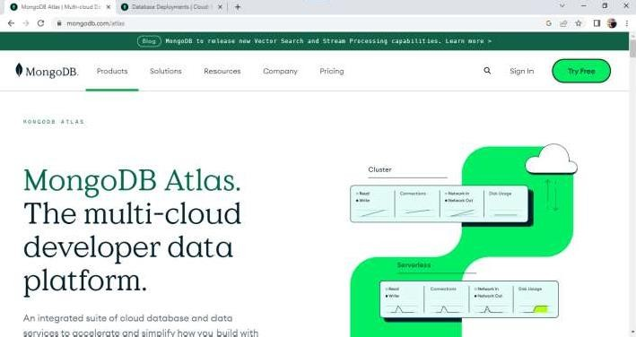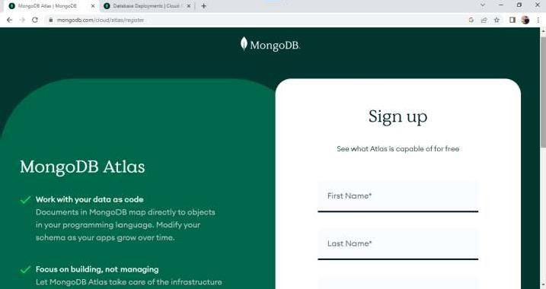

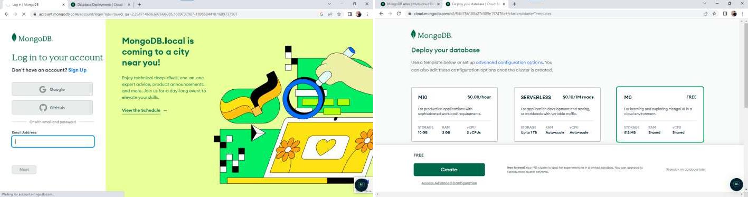

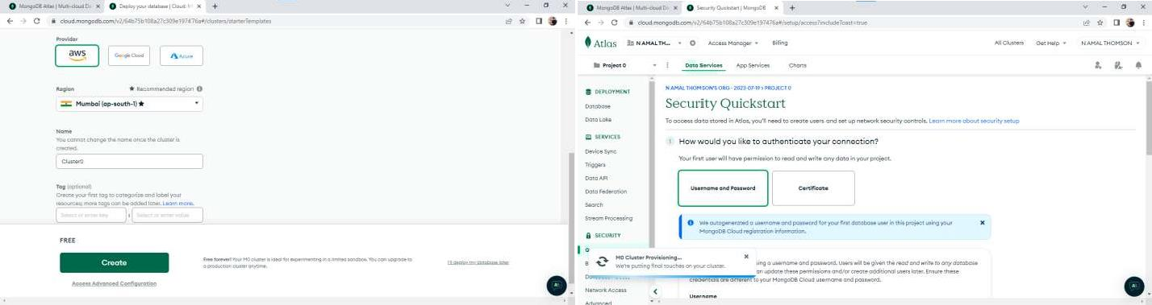

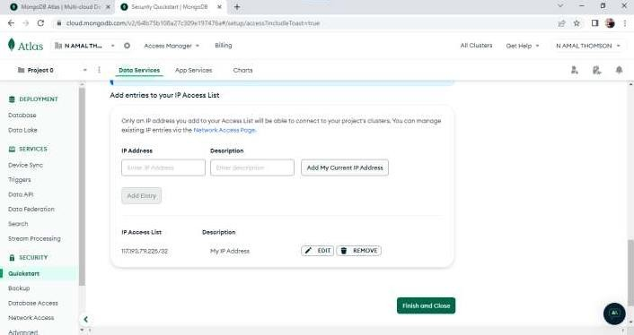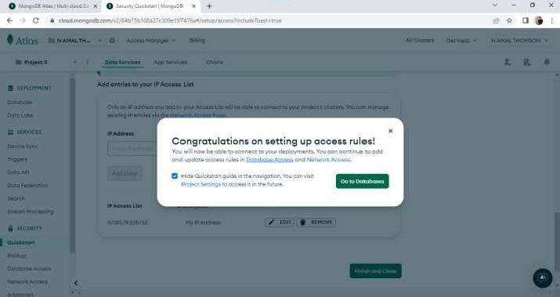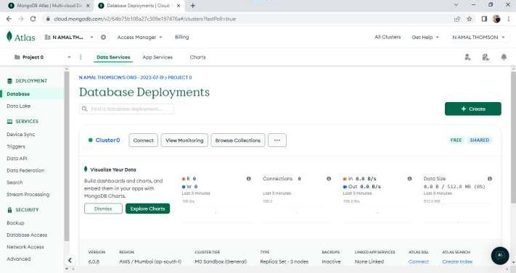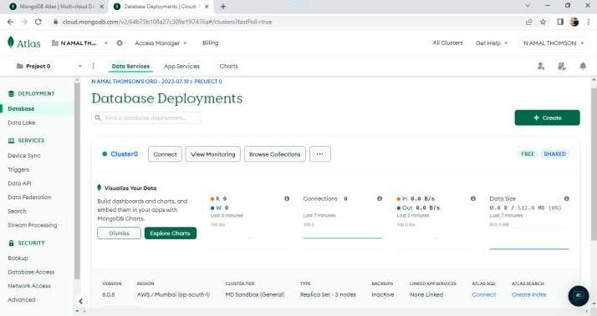

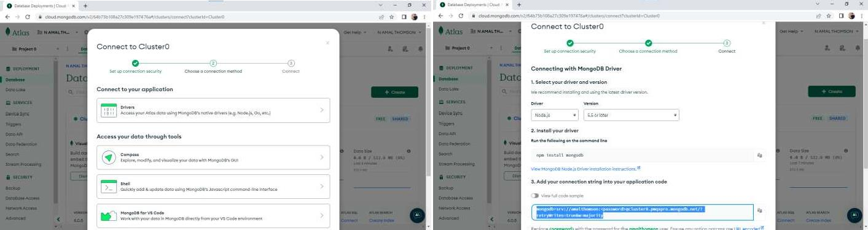

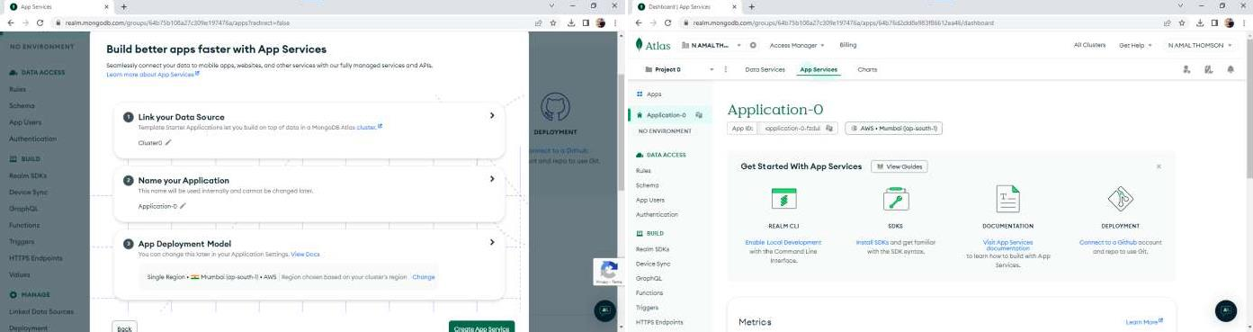

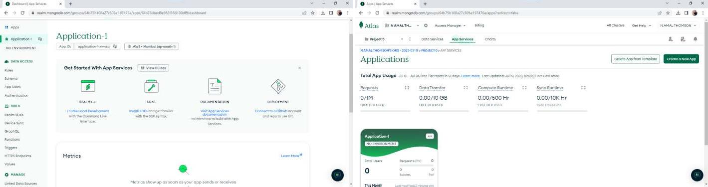

**Result**

The program was executed and the result was successfully obtained. Thus CO5 was obtained